Name: ___________________________________________________ Date: ______

Selecting Cookware

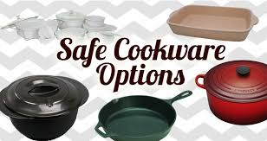 | Safe Cookware Guide: Safe cookware is a vital part of healthy cooking and is highly important in keeping you and your family healthy. Learn about cookware safety.
https://healthy-cookware.com/safe-cookware-guide/

Notes:

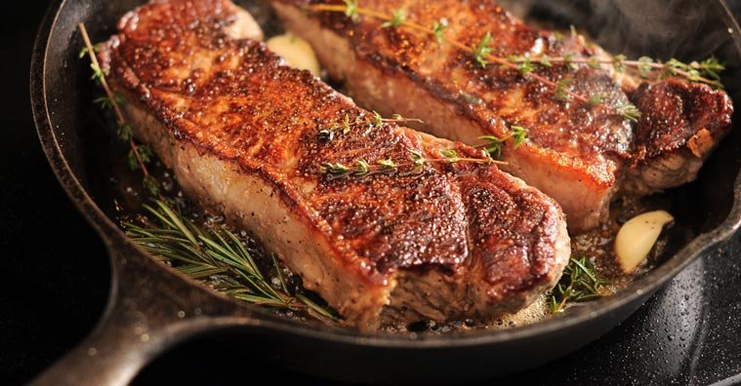 | How to Use the Right Pots and Pans for the Job  What’s the best pan to cook with?Here’s a guide to common cookware materials and which are best suited to cook your favorite food to perfection. Cooking to perfection has to do with thermal conductivity of the material of the cookware.
https://www.highya.com/articles-guides/guide-to-different-types-of-cookware-materials-and-their-uses

Notes:

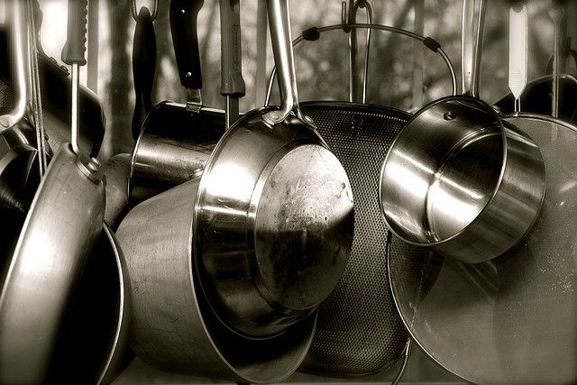 | What’s the Safest Cookware? Nonstick cookware is popular and easy, but it comes with disadvantages.
https://www.mnn.com/food/healthy-eating/questions/whats-the-safest-cookware

Notes:

Dangerous Cookware to Avoid: Some cookware can leach dangerous chemicals in your body.
*This is a 3 minutes YouTube video.
https://www.youtube.com/watch?v=YgCHVGG3Crk
http://www.meschinohealth.com/blog/cancer/2012/06/11/dangerous-cookware-avoid-titanium/
Notes:

